A Legacy That Keeps Giving: Y Service Club Supports North Side’s Newest School
What feels like a homecoming is, in truth, something even more meaningful, a continuation of a tradition rooted in community care and long-term impact.
For North Side Y Service Club member Ed, this moment carries a personal connection. Years ago, his son attended the former McAdam Avenue School, where the spirit of community investment was already alive and well. Back then, it was the dedication and hard work of club members that helped fund the tennis courts and ball fields, spaces that brought students and families together and left a lasting mark.
Today, that same spirit lives on.
The Y Service Club continues its proud tradition of supporting legacy projects that strengthen the community. With a generous $25,000 contribution at the Trailblazers recognition level, the club is helping fund in-ground basketball courts at Sunset Acres School, the newest school on the north side, set to open in September 2025. Stay tuned for the unveiling of the outdoor basketball courts, funded by the Y Service Club later this summer.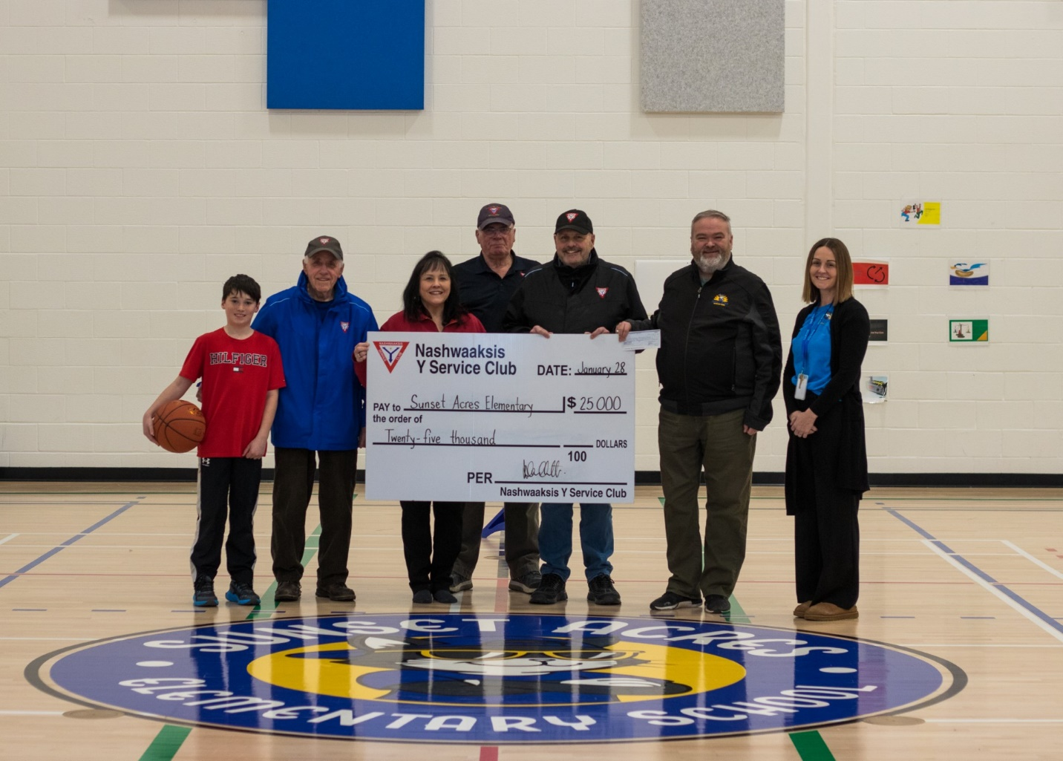
(Pictured are Sam Munn, an SAES student; Y Service Club members Ed Dunham, Kelly Price, Paul Gilmore, and Andre Ouellette; and SAES administrators Principal Jason Burns and Vice Principal Christie Jordan.)
From past to present, the Y Service Club’s commitment to community remains strong. Their investment is more than financial, it’s a belief in the future of the north side and the young people who will grow, learn, and play there.
Thank you to the Y Service Club for continuing to build community, one project at a time.
The SAES playground committee project is ongoing, and we invite you to be part of something impactful. With your support, we can add even more equipment to create a space for our students to learn, play, and grow. Every contribution makes a difference. To get involved or donate, contact Jason Burns or Christie Jordan.

