
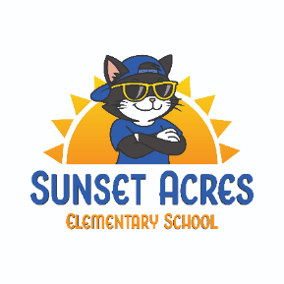
SUNSET ACRES ELEMENTARY SCHOOL
INFORMATION 2026-2027

contact us

Phone: (506)444-6200
Email: asdw.sunsetacreselementary@nbed.nb.ca
Website: https://sunsetacreselementary.nbed.ca
Principal: Jason Burns Jason.Burns@nbed.nb.ca
Vice-Principal: Christie Jordan
christie.jordan@nbed.nb.ca

mission, vision & slogan

- Mission: PAWS – Persevering, Accountable, Welcoming, Safe
- Vision: Inspiring leaders who make a PAWSitive difference in this world
- Slogan: Where everything is PAWSible

STAFF LIST & SCHOOL CALENDAR

Families can go to the Sunset Acres website to view the school calendar. https://sunsetacreselementary.nbed.ca/

school hours, tardiness, after school changes

Bell schedule:
Outdoor supervision begins: 7:40 a.m.
Morning bell/start time: 8:00 a.m.
Snack recess (K-2): 10:00 a.m. – 10:15 a.m.
Snack recess (3-5): 9:40 a.m. – 9:55 a.m.
Lunch (K-2): 12:05 p.m. – 12:25 p.m.
Lunch Recess (K-2) – 12:30 p.m. – 12:50 p.m.
Lunch (3-5) – 12:35 p.m. – 12:55 p.m.
Lunch recess (3-5): 12:05 p.m. – 12:25 p.m.
Dismissal: 2:15 p.m.
If your child arrives after 8:10, please ensure they sign in at the office before proceeding to class.
If your child will be leaving early, will be picked up instead of going on the bus, or in some way his/her routine is changed, please let your child’s teacher and the office know.
Please note that students will not be given permission to ride a different bus or get off
at a different stop unless it is a permanent change.

The school is not allowed to release your child to any person who is not on the contact list on the data collection form that is to be returned at the beginning of the year. This is for your child’s safety. If someone will be picking up your child and they’re not on your list on the form, please call the school.

SAFETY & drop-off and Bussing

The school and parents/guardians have a joint responsibility for all students from the time they leave home (or their parents’/guardians’ car) until they return. All school rules are to be followed while walking or riding the bus to and from school. Parents/guardians are to play a major monitoring role when students are between home and school.

Wondering if your child is zoned for a bus? You can check by visiting the district transportation site at: BusPlanner Web - BusPlanner Web. Early morning playground supervision begins at 7:40 am. As we are concerned about your child’s safety, your child may not arrive at school before this time.

The circular drive at the front of the school is for student drop-off and pick-up only. Please
note that drop-off is in ‘kiss and drop’ fashion. There will be a line of cars waiting to drop off their children, so the drop-off must be quick and efficient.

The circular drive at the back of the school is for bus traffic only. Please do not enter this drive. (see diagram)

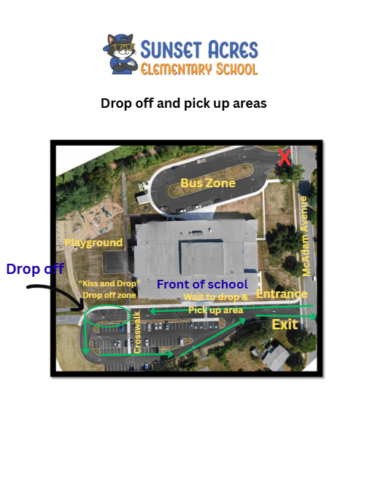

attendance/safe arrival

Attendance is compulsory unless sickness or a family crisis prevents your child from attending, as per the Education Act. Teachers are required to record any absences and the reason for the absence. Parents/guardians are expected to notify the school if their child will be absent. You can do this by emailing the teacher and office or by calling the school. Our school also uses the School Messenger app where you can report an absence.

If your child has missed a significant amount of school, the school will be reaching out to support you with more consistent attendance.

code of conduct / expectations

We have 3 expectations that students need to adhere to in all areas of the school, playground and bus:
Be safe
Be respectful
Be responsible

We take pride in providing a positive learning environment for our students and a positive working environment for our staff. If your child does not follow expectations, there will be age-appropriate consequences as well as learning opportunities about the school code of conduct.

Please note that serious offenses such as violence, racism and vandalism will result in suspension.

student leadership

Sunset Acres Elementary is proud to have an incredible grade 5 Student Leader program. Our Student Leaders have many responsibilities, including helping new students, assisting with activities and monitoring the playground. Applications are distributed to grade 4 students at the end of the year, and students are selected based on various criteria. There is mandatory training associated with being a Student Leader, and students must continue to be safe, responsible and respectful throughout the year to remain on the Student Leader team.

drills

As per District policy, we have regular safety drills throughout the school year. These drills include fire, lockdown, bus evacuation, site evacuation and medical emergencies.

homework

Each teacher will have expectations when it comes to completing homework. As a rule, please have your child read every night.

lost and found

Please be sure to label all your child’s belongings to keep them out of the lost and found pile. Lost and found articles are kept on the stage. Every week, the school will send home a picture of lost and found items so you can see if your child’s belongings are there. After a period of two weeks, accumulated items will be donated to local organizations.

communicable diseases

The Government of New Brunswick has provided schools with School Exclusion Guidelines for several communicable diseases, including pink eye, influenza, hand-foot-and-mouth, etc. If your child has been diagnosed with, or if you suspect that your child has a communicable disease, please check the guidelines which outline whether your child needs specific treatment or needs to stay home from school for a period of time. These guidelines can be found here:
https://www2.gnb.ca/content/dam/gnb/Departments/h-s/pdf/en/CDC/HealthProfessionals/SchoolExclusionGuidelines.pdf

Regardless of diagnosis, students should be fever-free for 24 hours without using fever-reducing medications, free of vomiting and/or diarrhea for 48 hours, and well enough to attend school and participate in all school activities like Physical Education and outdoor recess.

lice

An infestation of head lice most often affects children and usually results from the direct transfer of lice from the hair of one person to the hair of another. Head lice is not a sign of poor personal hygiene or an unclean living environment. Head lice do not carry bacterial or viral infectious diseases. Treatments are available at your local pharmacy, and we ask that if your child contracts lice that you complete at least one treatment before sending your child back to school.

field trips/co-curricular and extra-curricular activities

Parental permission is required for all class outings. At the beginning of the school year, we will send one permission slip home for parents/guardians to consent to outings for the school year. When your child’s class will be going on an outing, the classroom teacher will advise, or it will be in the school’s weekly email.

emergency numbers and contacts

It is very important that parents/guardians fill out the data collection forms at the beginning of the year and send them back to the school as soon as possible. If your child has attended school before, some of this information will already be populated. If your information has changed, please cross out errors and provide the new information.
If your information changes during the school year, please update the school in writing (note or email).

school closures

You can find a list of school closures in several ways. Local radio stations will announce closures, and they will be posted to the school website. You can also call 506-453-5454 or visit the District’s Twitter/X feed by searching Anglophone School District West. Closures are often based on Weather Zones. Fredericton is Weather Zone 6.

cashless schools

School Cash Online is an online parent portal that offers a safe, fast and convenient way to pay for school fees, such as supply fees, hot lunch, field trips, etc. Parents can register by visiting https://asdw.schoolcashonline.com.

supplies for students

We collect $55 per student via School Cash Online for school supplies, which allows our teachers to ensure students have consistent supplies. We are also able to purchase items in bulk and therefore receive a discounted rate on many items. You are responsible for providing your child with a backpack, lunch box, water bottle, box of tissues and box of large Ziplock bags. Your teacher may request other items such as headphones. School supply lists can be found on our website.

visitors

All visitors must sign in at the office. Visitors are not permitted to enter the school beyond the office area without permission. This enables us to always keep our students safe.

Please note that teachers and administrators are not available for unscheduled meetings. If you need to speak to your child’s teacher or the Principal or Vice-Principal, please call or email to make an appointment.

communications

The Principal will send home a weekly newsletter on Fridays, so please check your emails regularly. If you are not receiving these emails, please contact the office to ensure we have the correct email address.
Your child’s teacher will check in regularly to keep you updated on learning, activities, and your child’s progress. The best way to contact your child’s teacher is by email. However, if you need the school to know about something time-sensitive, such as a change in after school transportation or an emergency, please call the office. Teachers do not always have time to check emails during the day.

parent school support committee (Pssc)

The Parent School Support Committee (PSSC) brings together parents, students, staff, and community members to help make improvements to schools. Each school has a PSSC that advises and collaborates with the principal, other stakeholders and members to ensure that the school provides the best possible education for students.

If you would like to be a member of the PSSC, please contact the school or attend our Open House event in the fall for more information.

home & school committee

We have an amazing Home and School Committee (“Cool Cats Parent Crew”) that is always looking for new members! This committee puts the FUN in FUNdraising and is always organizing special events for the students and staff! If you would like more information, please reach out to the school.

report cards & conferences

Report cards are sent home 3 times per year, and parent/teacher conferences occur twice per year. The school will be in contact with you to sign up for conferences through an online booking system.

food programs

Our school runs several food programs, including breakfast, brown bag lunches, and weekly food backpacks. If you need support with food for your child, please reach out to the school to enroll in one of our programs.

medications & allergies

If your child has a medical condition and must take medication at school, or if your child carries an EpiPen, please contact the school for a form. We cannot administer any type of medication, including common painkillers, etc. without this form being filled out and signed.
Due to staff and student allergies, we are a nut-free and scent-free school.



Hot Lunch

Hot lunches will be available on school days, with a regular and vegetarian option offered each day. Milk will be included with each meal. Meals are prepared on site by Jobs Unlimited and ordered in advance online. Please see the website for more information.

